# 

**Deploying PHP Guestbook, Collect Logs With Elk Stack, Backup & Restore ETCD Cluster**

Contents

1 Introduction 3

2 Documentation 4

2.1 Kubernetes Documentation 4

2.2 Linux Commands and VIM Commands 4

3 Previous Guides 5

4 Deploying PHP Guestbook Application With Redis 6

4.1 Deploying Redis master instance 6

4.2 Creating the Redis Master Service 7

4.3 Deploying REdis Slave instance 8

4.4 Creating the Redis Slave Service 9

4.5 Deploying Guestbook FRONtend PHP Application 10

4.6 Creating the Guestbook frontend Service 12

4.7 Accessing Guestbook application 13

4.8 CleanUp the Resources 14

5 Collecting And Aggregating Logs With Elk Stack 15

5.1 Deploying Elasticsearch Cluster 15

5.2 Deploying Logstash as deployment kind 17

5.3 Deploying Filebeat as Daemonset kind 21

5.4 Deploying Kibana as deployment kind 21

5.5 Working with kibana dashboard 22

6 Backing up and Restoring ETCD in K8s Cluster 25

6.1 Installing and placing etcd binaries 25

6.2 Taking ETCD snapshot and verifying 26

6.3 Backing up the certificates and key files 26

6.4 Restoring ETCD from snapshot and verifying it 27

7 Summary 30

# Introduction

In this guide how to set up a cluster to ingest logs into Elasticsearch and view them using Kibana, as an alternative to Stackdriver Logging when running on GCE.

**Restoring an etcd cluster**

etcd supports restoring from snapshots that are taken from an etcd process of the major.minor version. Restoring a version from a different patch version of etcd also is supported. A restore operation is employed to recover the data of a failed cluster.

This guide Covers:

* Backing up and Restoring ETCD in K8s Cluster
* Collecting And Aggregating Logs With Elk Stack
* Deploying PHP Guestbook Application With Redis

# Documentation

## Kubernetes Documentation

1. Deploying PHP Guestbook application with Redis

<https://kubernetes.io/docs/tutorials/stateless-application/guestbook/>

<https://github.com/kubernetes/examples/tree/master/guestbook/>

1. Logging Using Elasticsearch and Kibana

<https://kubernetes.io/docs/tasks/debug-application-cluster/logging-elasticsearch-kibana/>

1. Backup and restore etcd cluster

<https://kubernetes.io/docs/tasks/administer-cluster/configure-upgrade-etcd/#:~:text=Restoring%20an%20etcd%20cluster&text=A%20restore%20operation%20is%20employed,from%20a%20remaining%20data%20directory>.

* 1. **Linux Commands and VIM Commands**

1. Basic Linux Commands

<https://maker.pro/linux/tutorial/basic-linux-commands-for-beginners>

<https://www.hostinger.in/tutorials/linux-commands>

1. Basic VIM Commands

<https://coderwall.com/p/adv71w/basic-vim-commands-for-getting-started>

1. Popular VIM Commands

<https://www.keycdn.com/blog/vim-commands>

# Previous Guides

Ensure that you have completed following activity guides:

* ***Note****: Follow Activity Guide* ***AG_Bootstrap_Kubernetes_Cluster_Using_Kubeadm_Guide_ed****\*\* from portal*
* ***Note****: Follow Activity Guide* ***AG_*** ***Deploy_App_On_Pod_&_Basic_Networking_ed****\*\* from portal*
* ***Note****: Follow Activity Guide* ***AG_Deploying_Scalable_and_Configuring_Autoscaling_For_Stateless_Application_ed****\*\* from portal*
* ***Note****: Follow Activity Guide* ***AG_Configuring_NFS_Storage_Persistence_Volume_ed****\*\* from portal*
* ***Note****: Follow Activity Guide* ***AG_Constraint_Pod_and_Node_Selector_Node_Affinity_&_Anti_Affinity_ed****\*\* from portal*
* ***Note****: Follow Activity Guide* ***AG_Cluster_Node_Maintenance_Debugging_Application_Failure_Troubleshooting_Cluster_ed****\*\* from portal*

# Deploying PHP Guestbook Application With Redis

Build and deploy a simple, multi-tier web application using Kubernetes and Docker. This exercise consists of the following components:

* A single-instance Redis master to store guestbook entries
* Multiple replicated Redis instances to serve reads
* Multiple web frontend instances

## Deploying Redis master instance

1. View Redis Master deployment yaml file and read through the configuration specified

$ vim redis-master.yaml

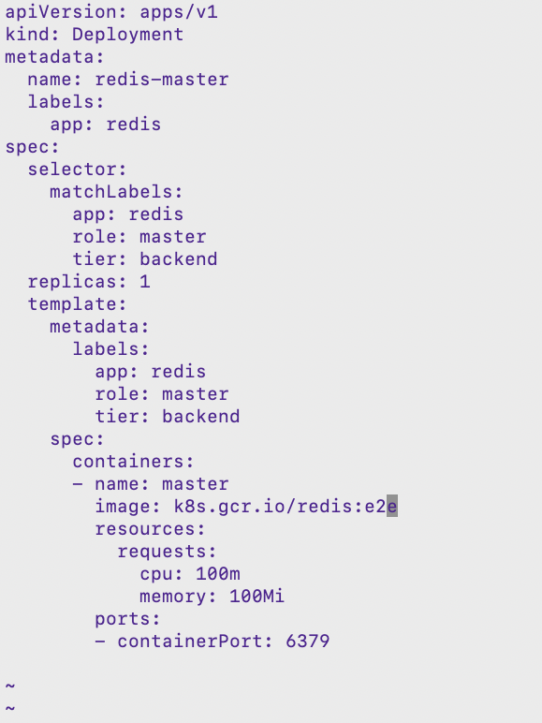

1. Create Redis master using the above yaml file and list all the created resources

$ kubectl create -f redis-master.yaml



$ kubectl get all

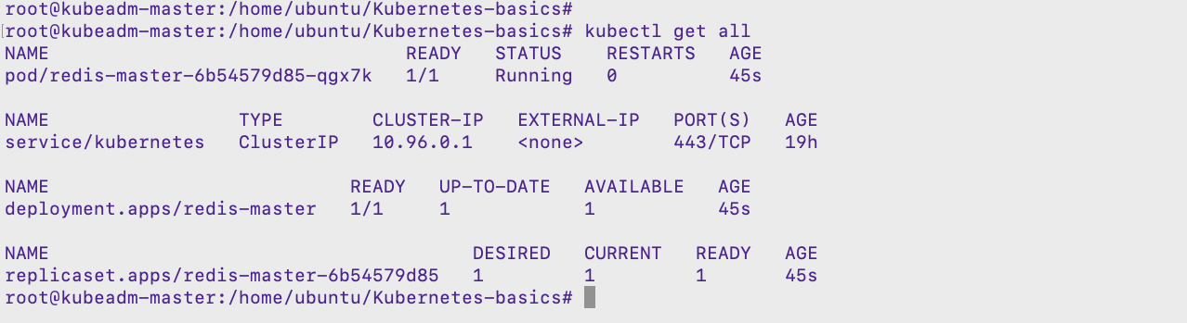

## Creating the Redis Master Service

1. The guestbook application needs to communicate to the Redis master to write its data. We need to apply a [Service](https://kubernetes.io/docs/concepts/services-networking/service/) to proxy the traffic to the Redis master Pod
2. View the content of the service yaml file for Redis Master

$ vim redis-master-svc.yaml

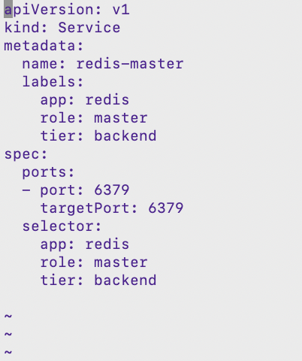

1. Create the Redis Master service using the above yaml file and list it

$ kubectl create -f redis-master-svc.yaml

$ kubectl get svc

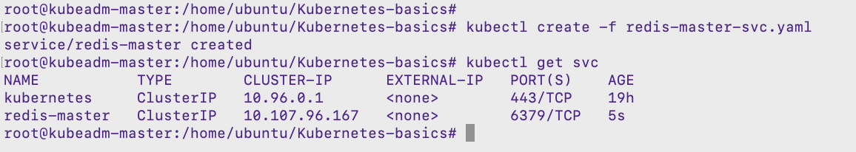

## Deploying REdis Slave instance

1. View Redis Slave deployment yaml file and read through the configuration specified

$ vim redis-slave.yaml

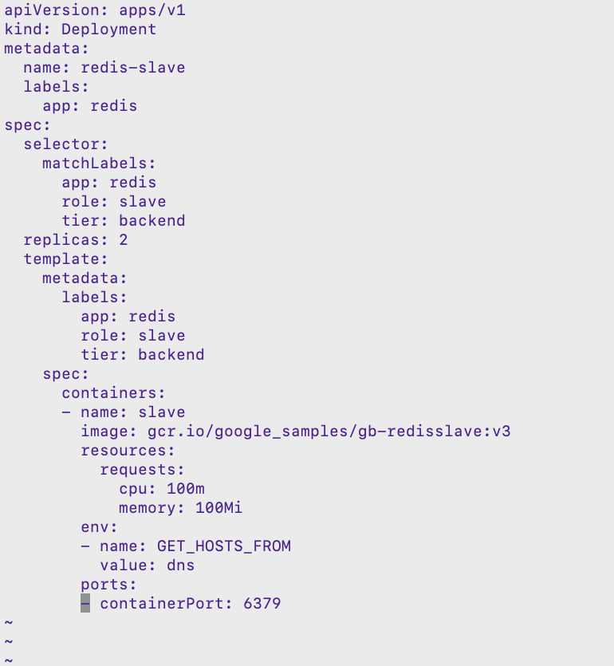

1. Create Redis Slave using the above yaml file and list all the created resources

$ kubectl create -f redis-slave.yaml



$ kubectl get all

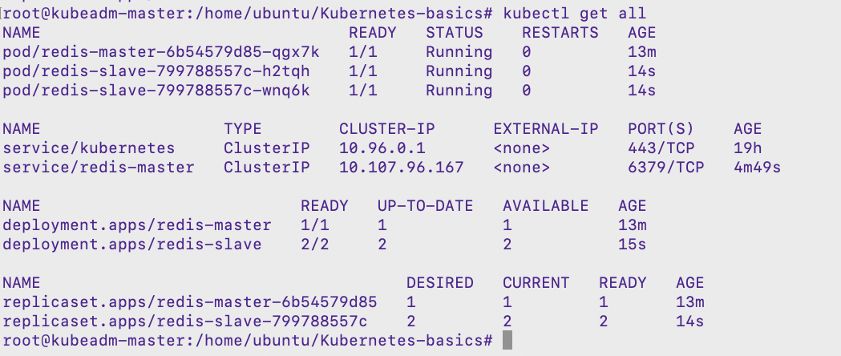

## Creating the Redis Slave Service

1. The guestbook application needs to communicate to the Redis master to read data.
2. View the content of the service yaml file for Redis Slave

$ vim redis-slave-svc.yaml

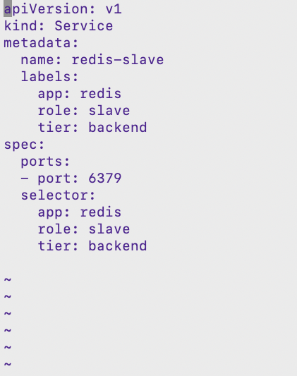

1. Create the Redis Slave service using the above yaml file and list it

$ kubectl create -f redis-slave-svc.yaml

$ kubectl get svc

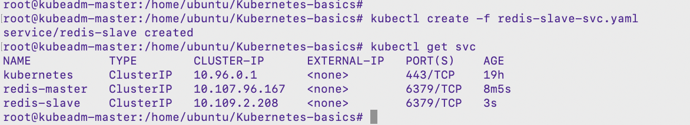

## Deploying Guestbook FRONtend PHP Application

1. View Guestbook deployment yaml file and read through the configuration specified

$ vim guestbook-frontend.yaml

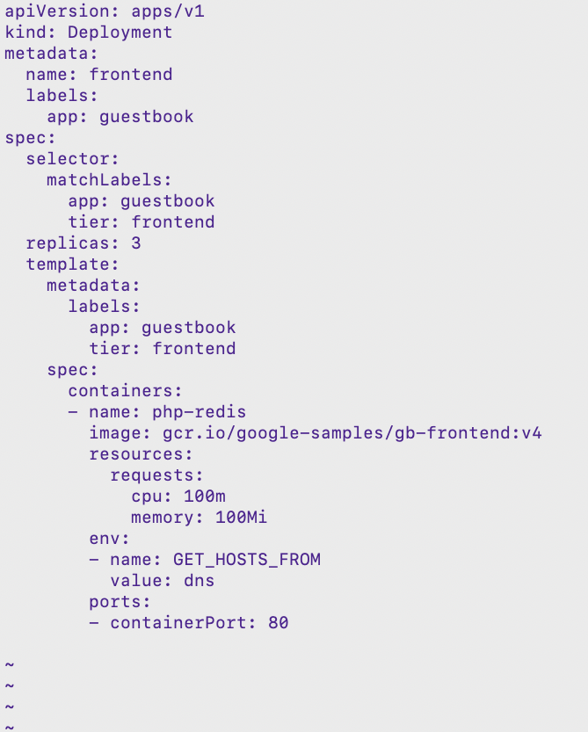

1. Create Guestbook deployment using the above yaml file and list all the created resources

$ kubectl create -f guestbook-frontend.yaml



$ kubectl get all

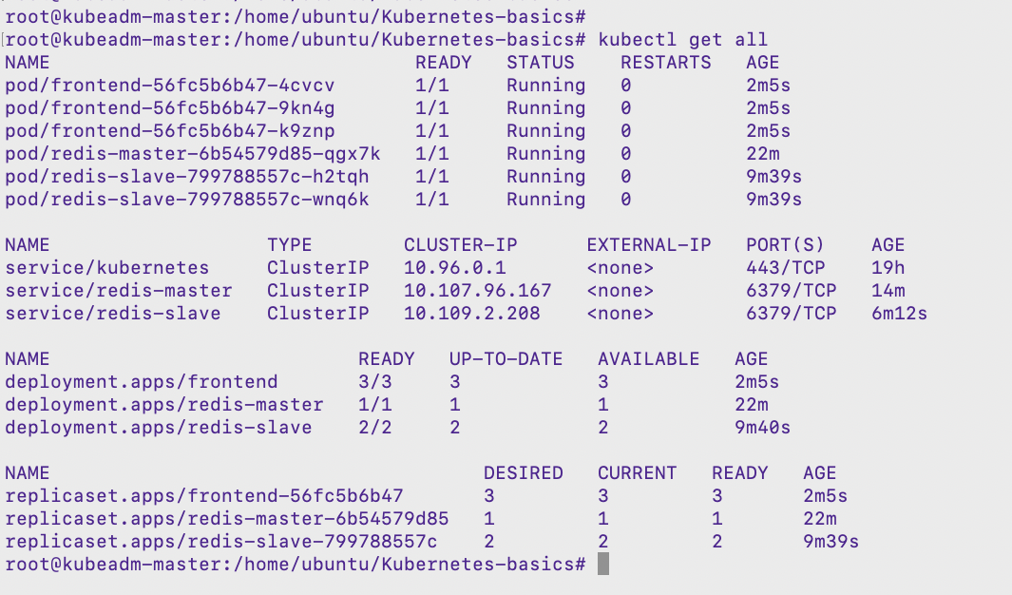

## Creating the Guestbook frontend Service

1. The guests needs to access the Guestbook Application from outside the cluster
2. View the content of the service yaml file for Guestbook Frontend

$ vim guestbook-frontend-svc.yaml

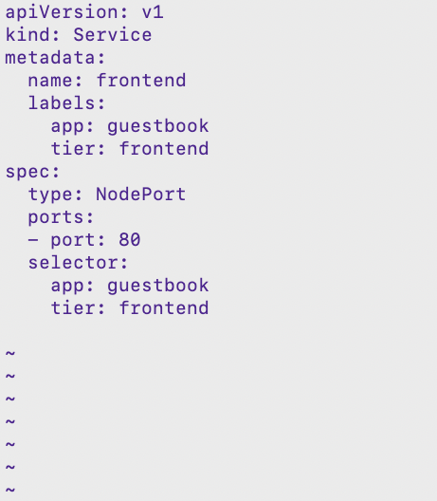

1. Create the frontend service using the above yaml file and list it

$ kubectl create -f guestbook-frontend-svc.yaml

$ kubectl get svc

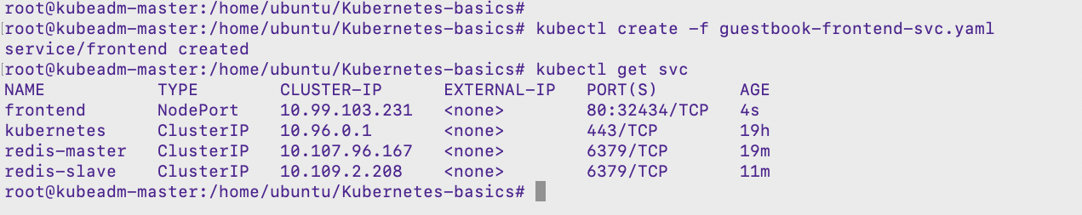

## Accessing Guestbook application

1. The Guestbook Application has Redis at the backend to persist the data. Type in some messages and verify that the messages are persisting after refreshing the web page too
2. Reach the Guestbook Application using Guestbook frontend svc Node Port number with any nodes Public IP address

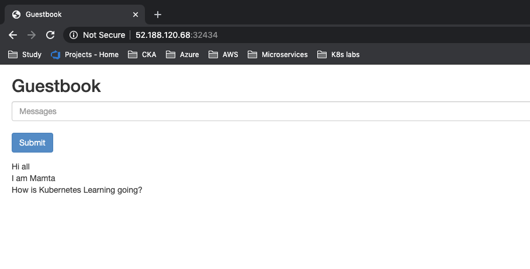

## CleanUp the R**esources**

1. Delete the secret and pod created during this lab exercise

$ kubectl delete -f redis-master.yaml

$ kubectl delete -f redis-master-svc.yaml

$ kubectl delete -f redis-slave.yaml

$ kubectl delete -f redis-slave-svc.yaml

$ kubectl delete -f guestbook-frontend.yaml

$ kubectl delete -f guestbook-frontend-svc.yaml

# Collecting And Aggregating Logs With Elk Stack

## Deploying Elasticsearch Cluster

1. Create a service account for Elasticsearch so that it has read access to [services](https://www.magalix.com/blog/kubernetes-services-101-the-pods-interfaces), namespaces, and endpoints. View the configuration specification in below yaml file. File is available from the cloned repo.

$ vim elasticsearch-rbac.yaml

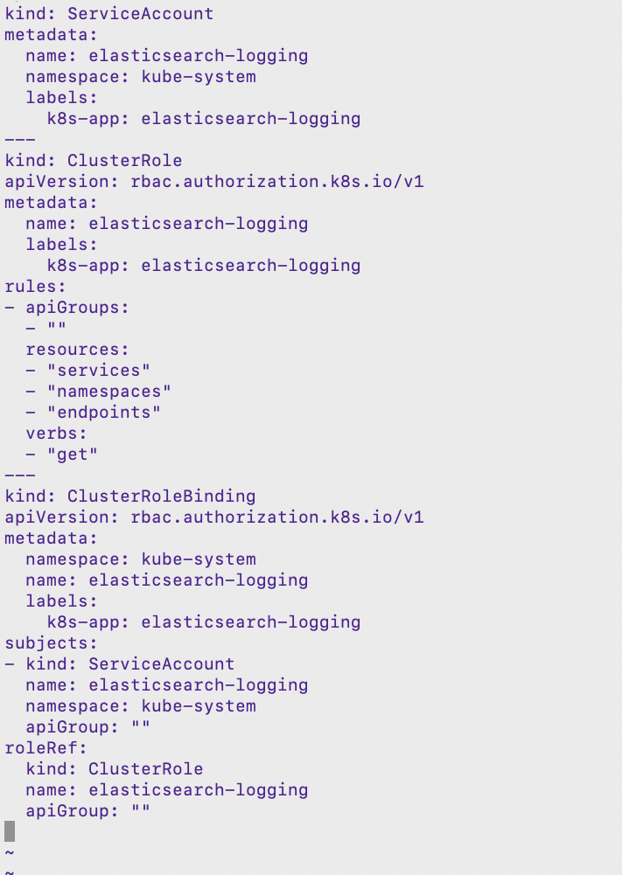

1. Creating resources using the elasticsearch-rbac.yaml file

$ kubectl create -f elasticsearch-rbac.yaml

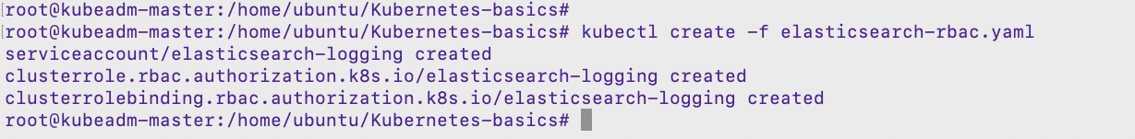

1. Creating Elasticsearch cluster with Statefulset controller. File is available from the cloned repo.

$ vim elasticsearch.yaml

$ kubectl create -f elasticsearch.yaml



1. Wait for both the replicas of Elasticsearch Statefulset to be up and running

$ kubectl get sts -n kube-system

$ kubectl get pods -n kube-system

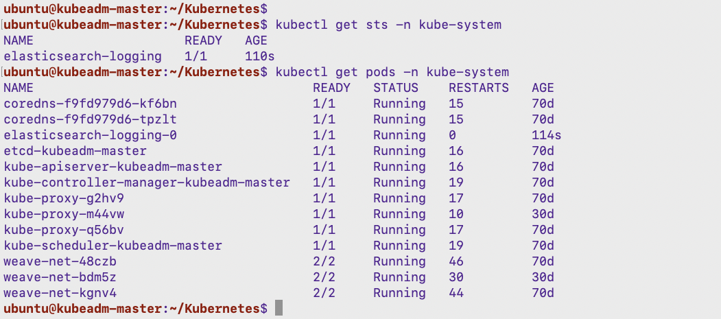

1. Creating Service through which we can access the Elasticsearch databases. File is available from the cloned repo.

$ vim elasticsearch-svc.yaml

$ kubectl create -f elasticsearch-svc.yaml

$ kubectl get svc -n kube-system

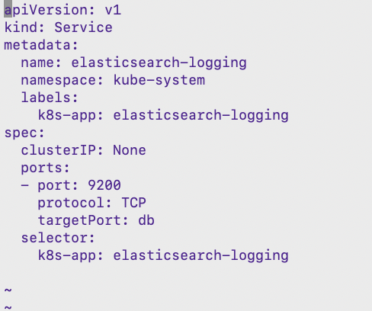

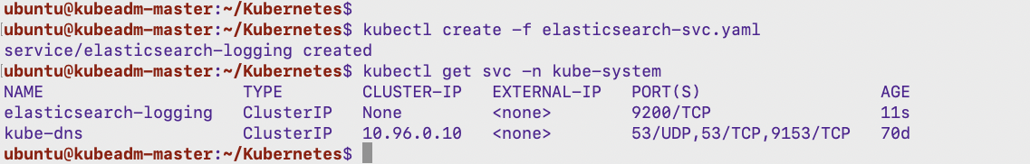

## Deploying Logstash as deployment kind

1. Create a ConfigMap for Logstash configuration setting. File is available from the cloned repo.

$ vim logstash-configmap.yaml

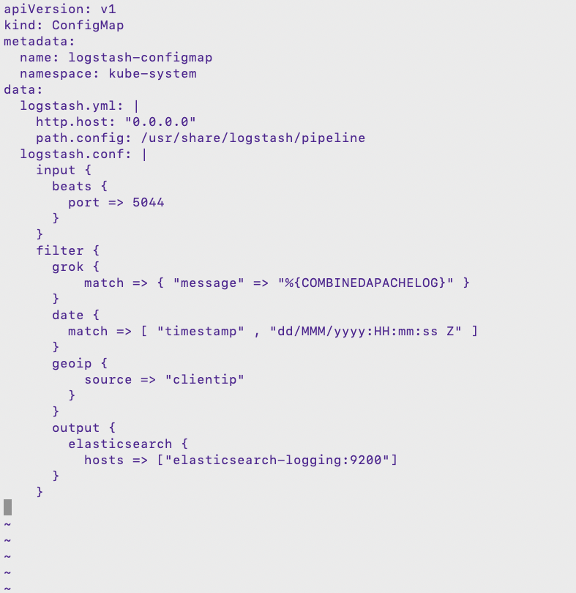

1. Creating ConfigMap resource using the logstash-configmap.yaml file. File is available from the cloned repo.

$ kubectl create -f logstash-configmap.yaml

$ kubectl get configmap -n kube-system

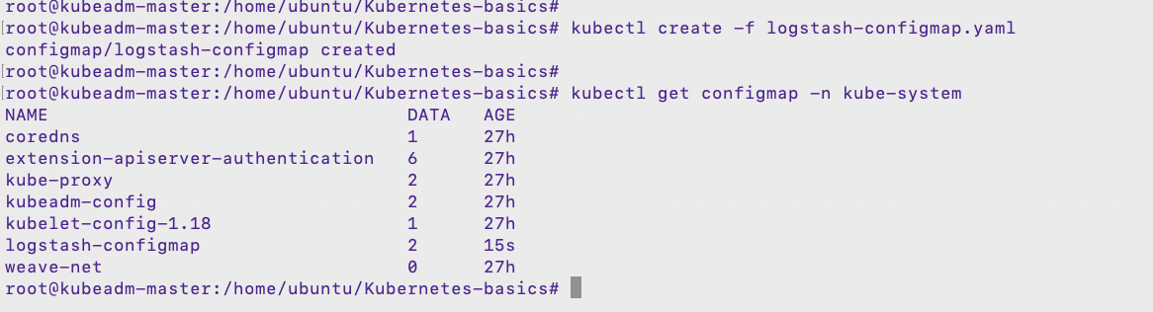

1. Creating Logstash as Deployment kind. File is available from the cloned repo.

$ vim logstash-deployment.yaml

$ kubectl create -f logstash-deployment.yaml

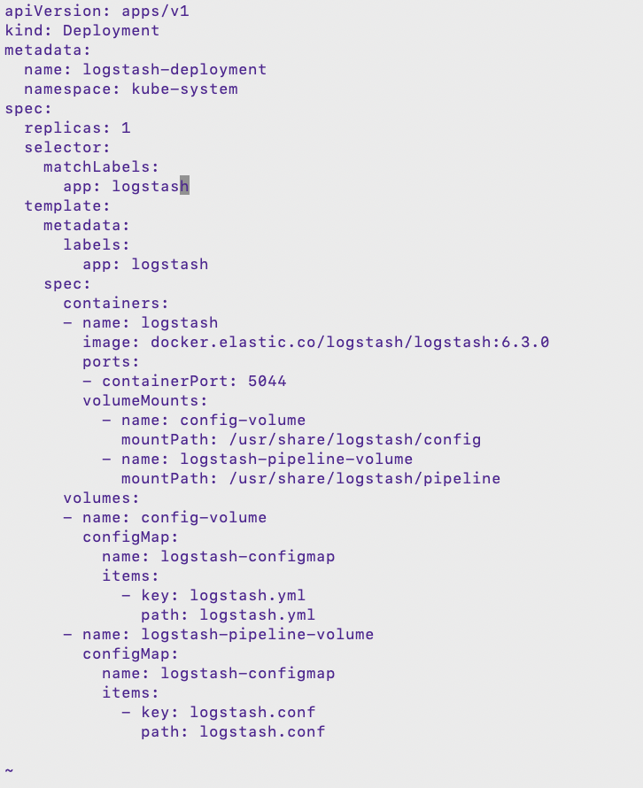



$ kubectl get all -n kube-system

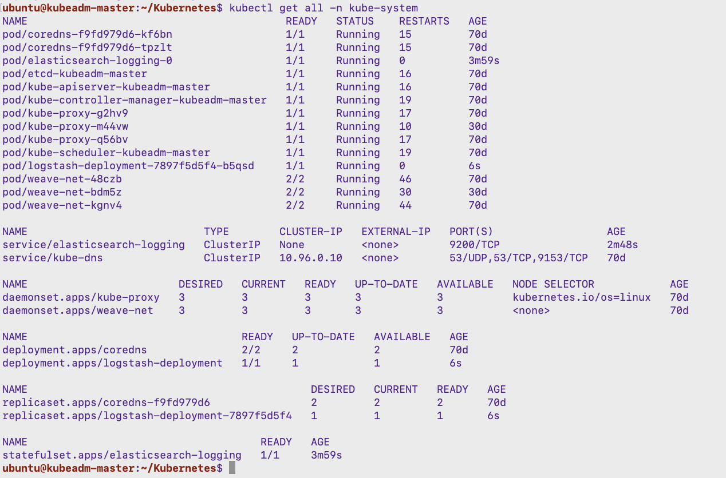

1. Creating Service through which we can access the Logstash. File is available from the cloned repo.

$ vim logstash-svc.yaml

$ kubectl create -f logstash-svc.yaml

$ kubectl get svc -n kube-system

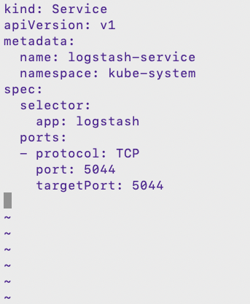

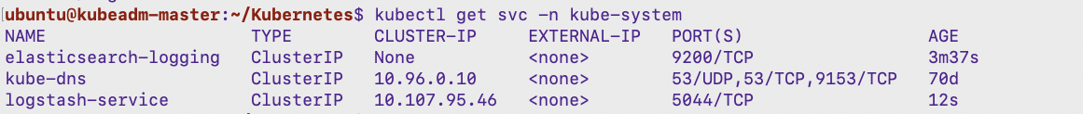

## Deploying Filebeat as Daemonset kind

1. Create Filebeat agent to run on all nodes in the cluster as Daemonset. File is available from the cloned repo.

$ vim filebeat-agent.yaml

1. Deploying all resources related to Filebeat agent using the above yaml file

$ kubectl create -f filebeat-agent.yaml

$ kubectl get ds -n kube-system

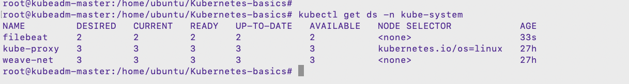

## Deploying Kibana as deployment kind

1. Deploy Kibana dashboard to on high available mode in the cluster and also create service to reach the dashboard UI from the external world

$ vim kibana-elk.yaml

1. Deploying all resources related to Kibana using the above yaml file

$ kubectl create -f kibana-elk.yaml

$ kubectl get all -n kube-system

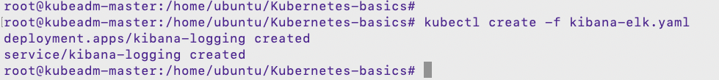

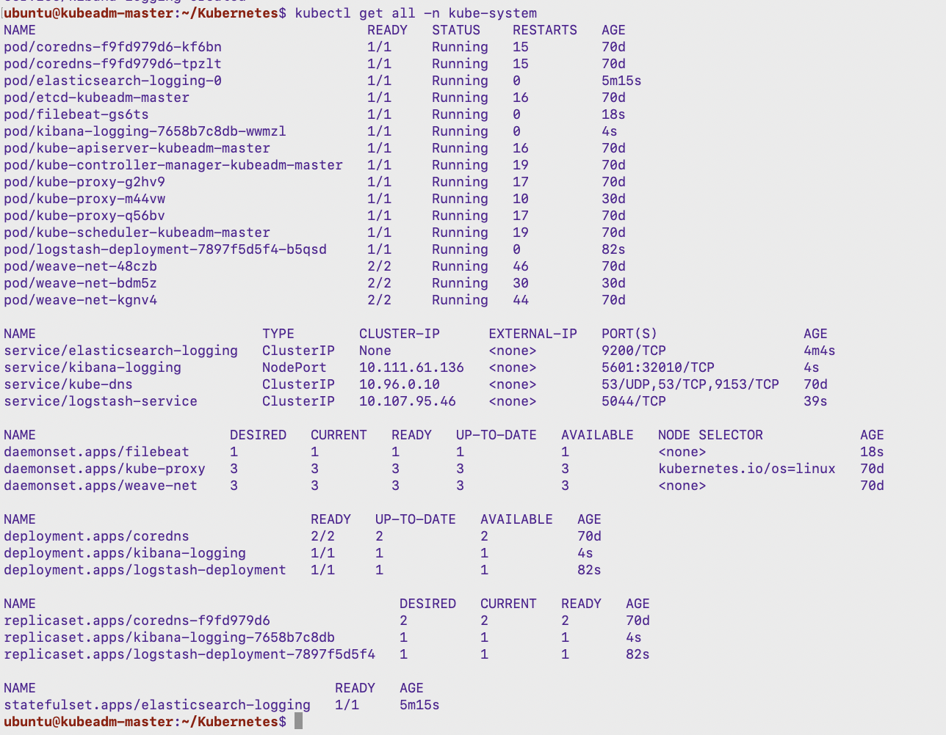

1. Access the Kibana dashboard from the web browser using the Kibana Service Nodeport and Node’s Public IP Address

$ <http://52.188.120.68:32010/>

## Working with kibana dashboard

1. We should see Kibana’s dashboard, click on “Skip” to avoid Kibana adding sample data. Now, click on Discover on the left panel. Create new index pattern to pull logs. We should see something similar to the following:

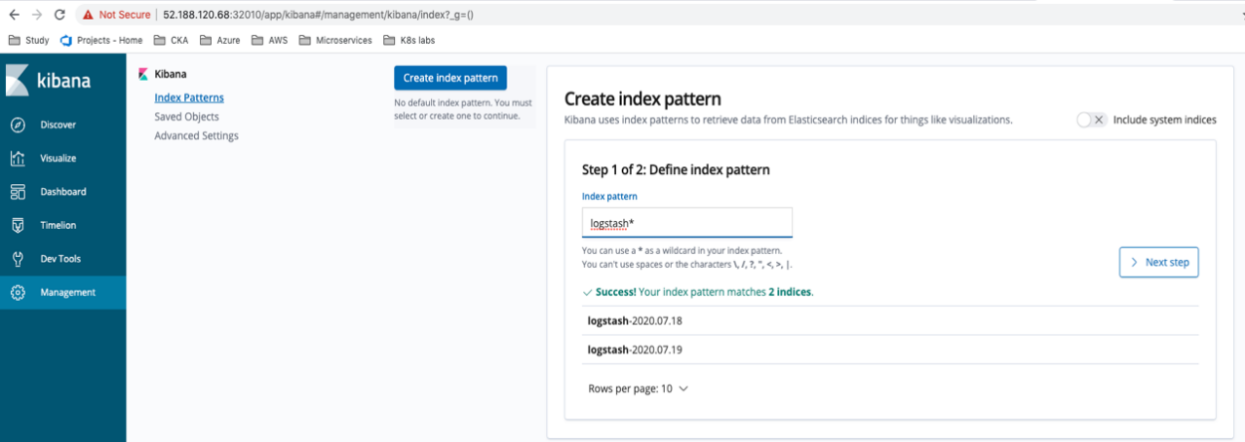

1. Type logstash* as the index pattern. This instructs Kibana to query Elasticsearch’s indices that match this pattern. Click “Next step”.

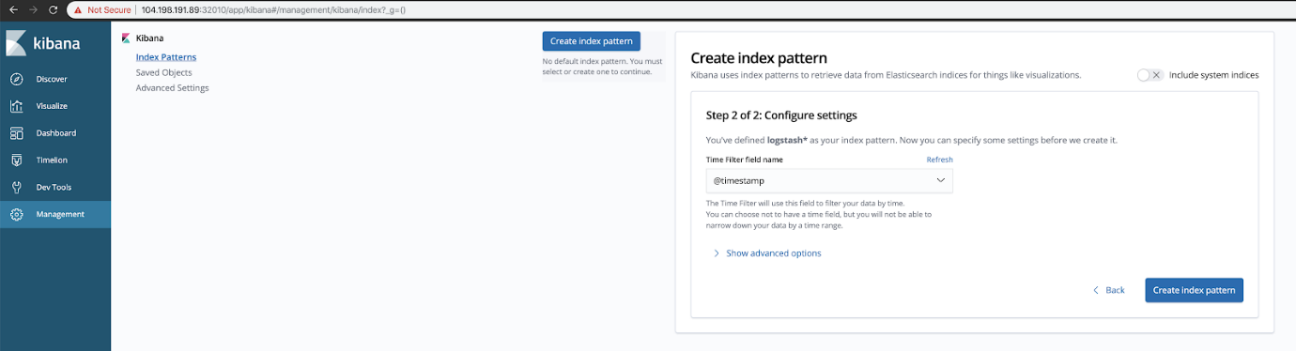

1. Select @timestamp as the Time Filter field name and click “Create index pattern”.

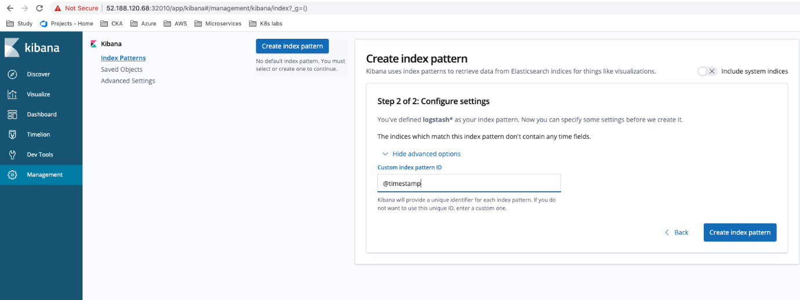

1. The index will get created in a few seconds. Now click on “Discover”. You should see something like the following:

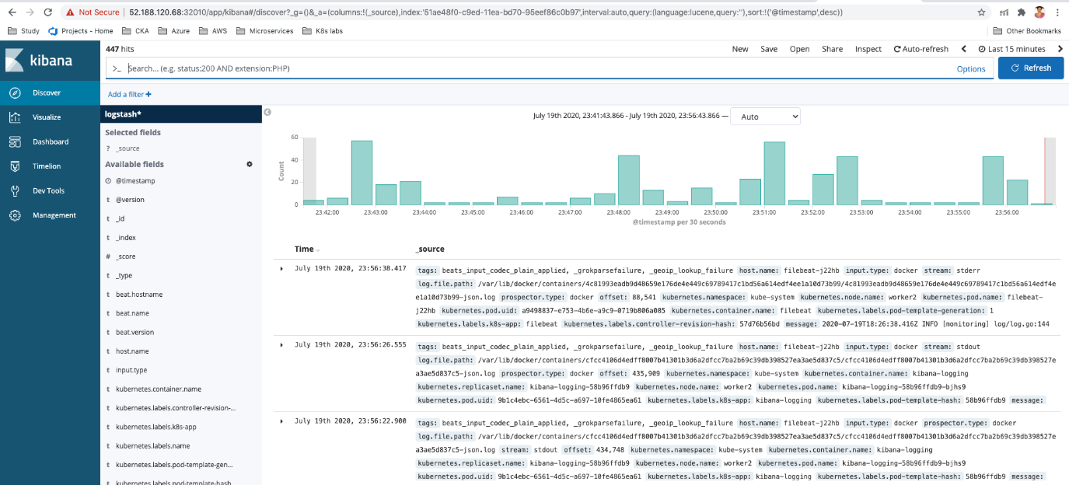

## Accessing Application logs on Kibana Dashboard

1. Deploy nginx-deployment application using nginx-deployment.yaml file

$ kubectl create -f nginx-deployment.yaml

$ kubectl get pods

$ kubectl get deployment

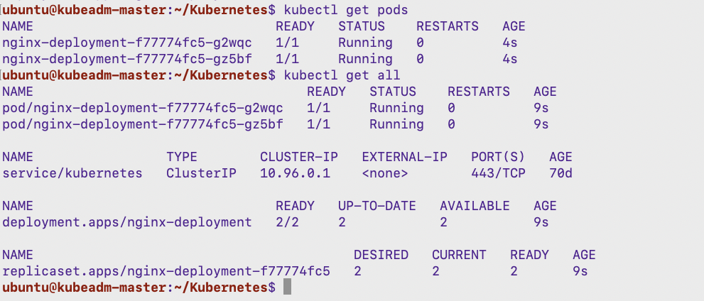

1. Expose application using kubectl expose command

$ kubectl expose deployment nginx-deployment --port 80 --target-port 80 --type NodePort

$ kubectl get svc

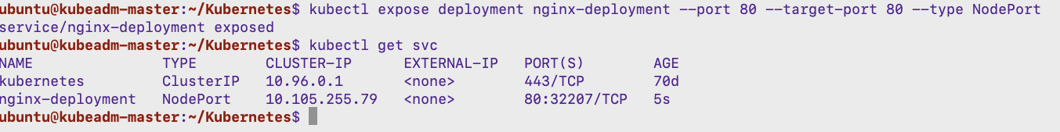

1. Creating a load-generator pod which shall create continuous request on the nginx server. Open a separate ssh terminal/putty session and set the cluster config on that terminal and execute the below command to create a new pod

$ kubectl run -it --rm load-generator --image=busybox /bin/sh



1. Execute an infinite loop to load the nginx-hpa application pods (any worker nodes’s public ip address with the nodeport allocated for the nginx-hpa service)

# while true; do wget -q -O- http://52.167.50.119:32207; done



1. Access Kibana dashboard on the top search bar type nginx string and click on refresh. You should be able to see nginx application logs.

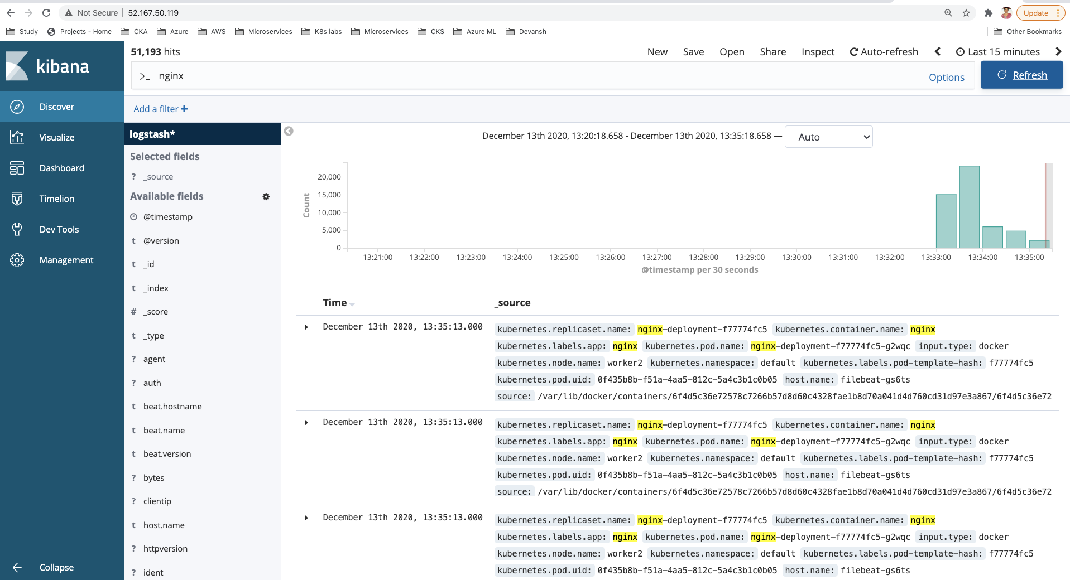



## Cleaning up the resources

1. Exit from the load generator pod by pressing ctrl c and then type exit. We will leave the ELK stack running in the cluster.

# Backing up and Restoring ETCD in K8s Cluster

## Installing and placing etcd binaries

1. Get the etcd binaries:

$ wget <https://github.com/etcd-io/etcd/releases/download/v3.3.12/etcd-v3.3.12-linux-amd64.tar.gz>

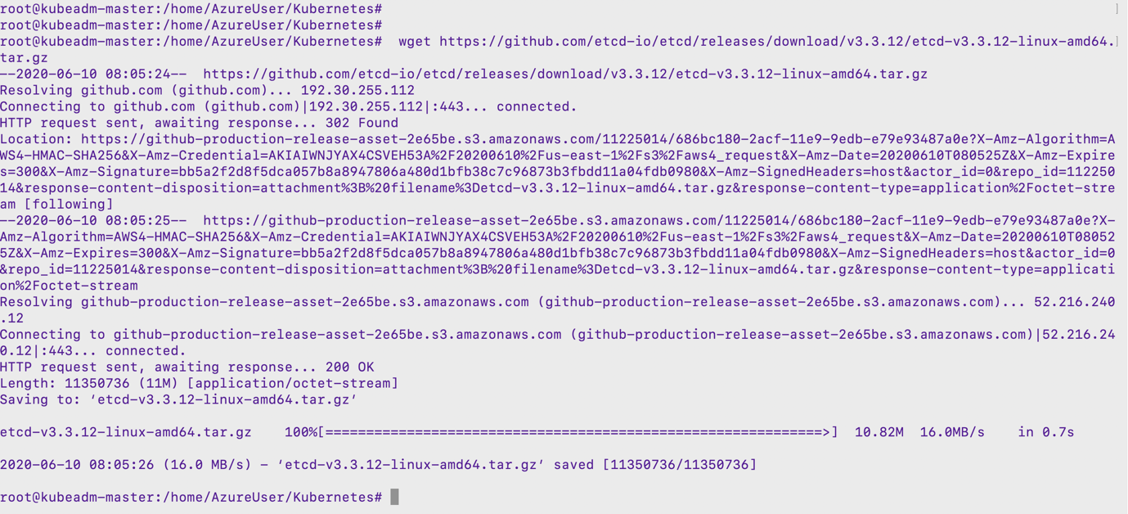

1. Unzip the compressed binaries:

$ tar xvf etcd-v3.3.12-linux-amd64.tar.gz

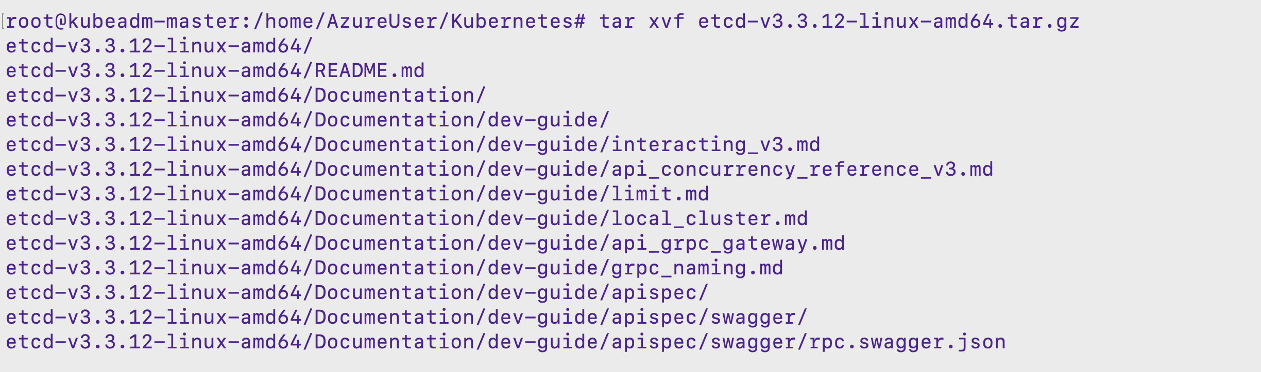

1. Move the files into /usr/local/bin:

$ sudo mv etcd-v3.3.12-linux-amd64/etcd* /usr/local/bin



## Taking ETCD snapshot and verifying

1. Take a snapshot of the etcd datastore using etcdctl:

$ sudo ETCDCTL_API=3 etcdctl snapshot save snapshot.db --cacert /etc/kubernetes/pki/etcd/ca.crt --cert /etc/kubernetes/pki/etcd/server.crt --key /etc/kubernetes/pki/etcd/server.key



1. View that the snapshot was successful:

­­$ sudo ETCDCTL_API=3 etcdctl snapshot status snapshot.db

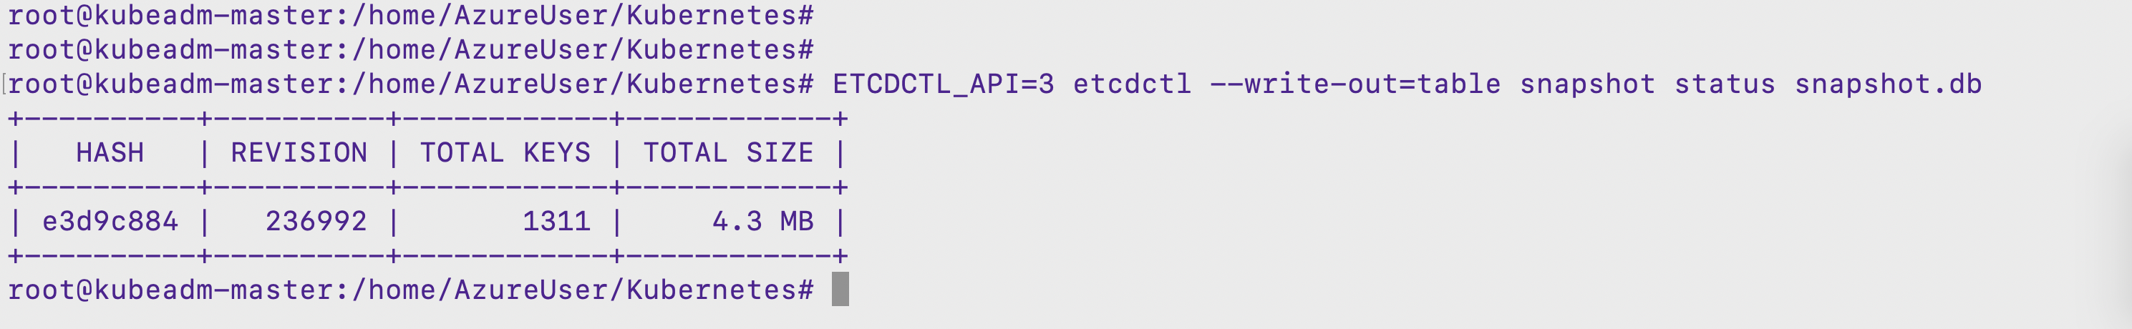

## Backing up the certificates and key files

1. Zip up the contents of the etcd directory to save the certificates too

$ sudo tar -zcvf etcd.tar.gz **/etc/kubernetes/pki/etcd**

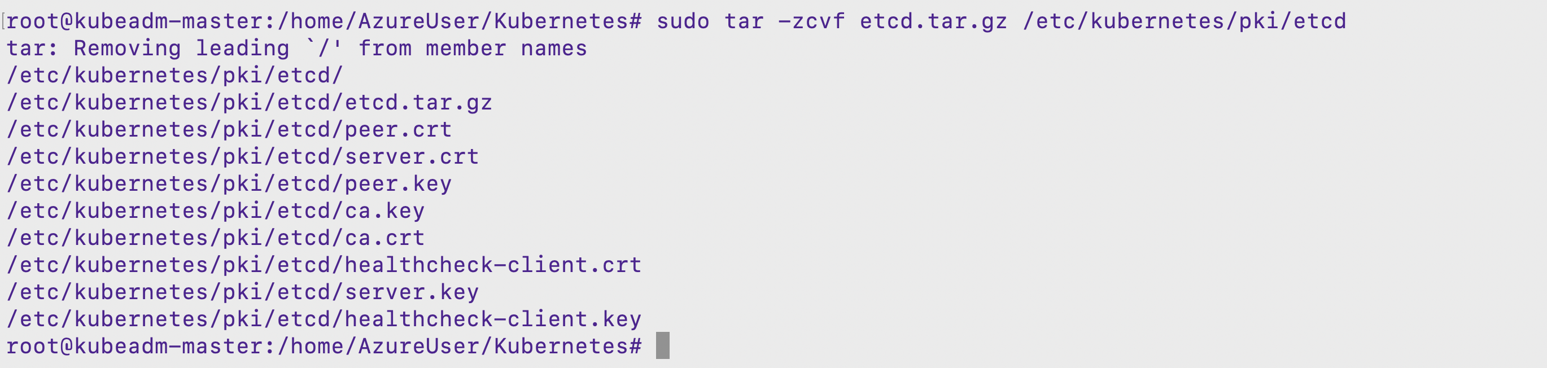

## Restoring ETCD from snapshot and verifying it

1. Check the present state of the cluster which is stored in present snapshot taken in above task

$ kubectl get all

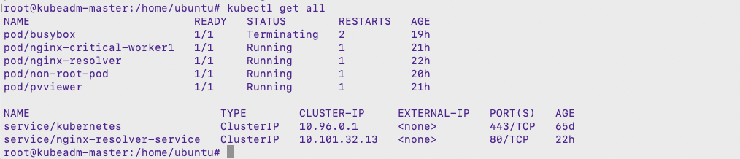

1. To verify now we will create a pod and as the new pod is not present in the snapshot will not be present when we restore the content back using restore command

­­$ kubectl run --generator=run-pod/v1 testing-restore --image=nginx

$ kubectl get pods

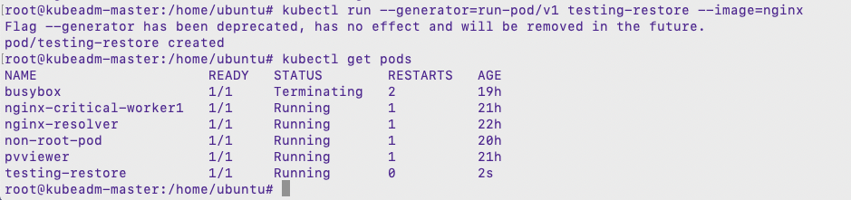

1. To restore we will have to first delete the present etcd content. So lets look into and grab all the details we need for the restore command to execute

$ cat /etc/kubernetes/manifests/etcd.yaml

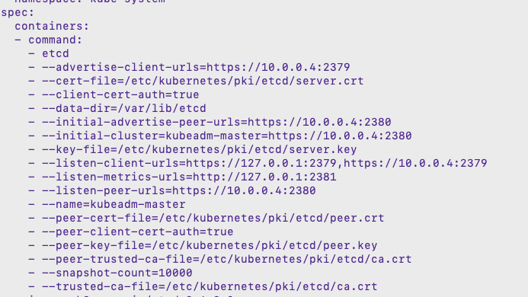

1. Will delete the present content of etcd and execute the restore command

$ rm -rf /var/lib/etcd

$ ETCDCTL_API=3 etcdctl snapshot restore snapshot.db --endpoints=https://127.0.0.1:2379 --cacert=/etc/kubernetes/pki/etcd/ca.crt --cert=/etc/kubernetes/pki/etcd/server.crt --key=/etc/kubernetes/pki/etcd/server.key --name=kubeadm-master --data-dir=/var/lib/etcd --initial-cluster=kubeadm-master=https://10.0.0.4:2380 --initial-cluster-token=etcd-cluster-1 --initial-advertise-peer-urls=https://10.0.0.4:2380



1. Verify that the cluster is back to status of which we had taken the snapshot

$ kubectl get pods

$ kubectl get all

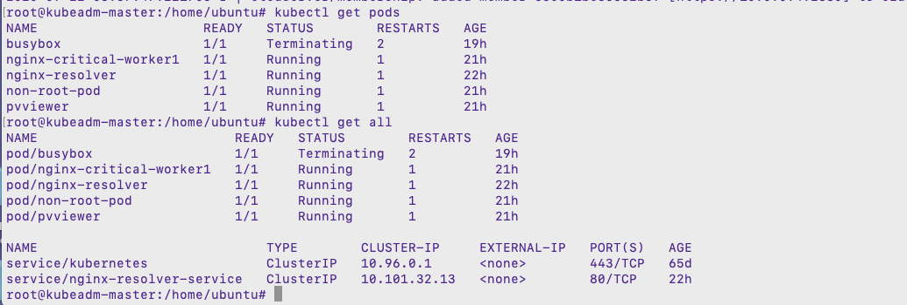

# Summary

In this guide we Covered:

* Backing up and Restoring ETCD in K8s Cluster
* Collecting And Aggregating Logs With Elk Stack
* Deploying PHP Guestbook Application With Redis